WOULD WE DEVELOP THE Imperial Cave NOW?
Ernst Holland 2000.

Introduction.

One of the most complex decisions a cave manager has to address is: what are the advantages of developing a new cave? The number of considerations that have to be addressed include financial viability, environmental matters, social and stakeholder perceptions.

The Imperial Cave at Jenolan was opened up for public inspection almost immediately on discovery in 1879 and development has been ongoing since then, with some restoration also taking place. One often wonders would this cave be developed today given the above matters that would need to be addressed?

If developed today would it be done the same way or would a tunnel be put in from the inner end to make a through tour exiting via McKeowns Valley?

The idea of this paper is to attempt to explore what may have happened then and what would happen today.

CONSIDERATIONS by the ADMINSTRATORS.

Costs of Services.

While they were experimenting with electricity at the time of the original opening of the Imperial Cave it was seen more as a novelty than the sole method of lighting a cave. Therefore one would imagine that the cost of lighting the tour would have comparatively been a lot cheaper than today. One would imagine the major costs would be the labour used to modify the cave for easier access. Most pathways were constructed from original material in the cave and it was not until the 1970s that the cement pathways were laid.

It is interesting to note though while today one is concerned with Lampen flora, visual and physical pollution caused by today’s electrical fittings, Jeremiah Wilson was concerned about soot and smoke from candles and magnesium ribbon.

Revenue Generation.

There are two avenues that must be looked at when assessing financial viability for the development of a new cave. That is revenue generated when the cave is first opened and offered as a new product, and then the long-term return. This will often bring about conflict between the administrator and some other stakeholders (possibly when it is public property) as to what the charges should be for entry to the cave.

This is because a number of stakeholders often see that public property should have so called ‘affordable access’ with most political groups supporting this philosophy. The administrator is under pressure to make it pay while there is another view that as this is an environmental asset there should be higher entry fees to pay for the use of the natural environment. None of these considerations would have occurred to the administrators in 1879 even though the government would have set the entry fees for Jeremiah Wilson. It interesting that these entry fees are seen today as affordable for the higher end of the society.

Social Issues.

There are a number of social issues that come from the development of a new cave for tourism and the very first is the different perspectives on the need for such a cave. While the administrators see it as a new product (and this proved the case when they first developed the Imperial), and therefore attractive to the customers, stakeholders will sometimes see new development simply as a money-spinner.

Jeremiah Wilson simply provided a service that was already in demand from the visitors who could afford to get to Jenolan and he would make some money too.

Visitor Satisfaction.

Visitor satisfaction has different meanings to different people and even different cultures and if it is got wrong it can have implications for the viability of any new development.

Because Jenolan was something of a mystery at that time of the Imperial Cave opening, just by getting there and seeing a cave, visitor satisfaction was guaranteed. It may be assumed that by having that air of adventure and mystery that there would not have been any so called ‘expectations’ that can be instilled today by advertising and marketing.

Stakeholder Interests.

There are a number of stakeholders who are deemed as having a vested interest in the development of a cave. The interests are diverse ones such as transport, tourism, staffing issues, business people seeing the added attraction as being beneficial, conservation groups concerned with environmental issues, and scientists often wishing to protect an important feature.

EIS ISSUES.

Cave modification.

While there is a lot to learn about cave physics, research has given some insights to how cave visitors may interfere with and possibly alter those physics. Work done overseas and at Jenolan show three possible causes that may alter cave physics. These are: visitors; cave modification; and the cave furniture, or man made infrastructure.

The original tours, while low in numbers, by the use of naked flames for lighting may have caused temperature changes as well as the pollution mentioned by Jeremiah Wilson. While I have already mentioned the modification to the Imperial Cave, it is to be noted that this would have been the heaviest modification ever done to the internal morphology of any other at Jenolan. Not only would this have changed airflows in the cave but may have removed some very valuable sedimentary deposits as well.

The main modification has been the bypassing of the original entry via Kings Tableland. This was by digging of a tunnel through old cave fill that is now the entrance to all caves on the south side of the Grand Arch making it the first tunnel ever to be dug at Jenolan.

Today this would be a major issue with many parameters to be considered and as suggested in my conclusions there may even be the bigger issues of a tunnel from McKeowns valley to make it a through cave tour.

Hydrological implications.

While it would be safe to say that there has not been any major hydrological impacts to the main northern stream (the Imperial River) by the development of the Imperial Cave (There was a major impact to that stream when the small wall was built for the Leffel Wheel), there has been a definite impact to natural water flows in the Imperial Cave above the stream level. The building of pathways and the blocking and removal of pool rims caused this, and water quality can be affected by rubbish off the pathway.

It is worth noting that, world wide, pool deposits were often sacrificed for pathways as they were perceived as not what people wanted to see.

Today an Environmental Impact Statement would have to give major consideration to water quality and hydrological changes because of Jenolan location at the top of a very important catchment. Today one would look at suspended pathways to overcome this problem.

Cultural impacts.

While there has never been any evidence that the indigenous people either used or had culture significant attached to the Imperial Cave there would be a need for a qualified person to have a closer look. What is interesting here is that by developing the Imperial when they did, there have been major cultural and heritage items added to Jenolan.

Paleontological impacts.

Anybody going through the Imperial Cave today would either notice or have pointed out to them the many bone deposits. At the time of the original opening the bones may have been seen as an added attraction to the cave without any thought to their importance and would not have been considered as a reason not to open the cave.

An Environment Impact Statement would consider the importance of such bones and either suggest that they be studied before the cave was opened and then the pathways and lighting so designed to minimise impact or that the cave not be developed at all.

This is an example of where stakeholder power could be the deciding factor.

Ascetics or Amenity.

In any development ascetics is a very controversial issue with many different points of views as to what it really means. The Imperial Cave without any doubt was originally developed to maximise the view of the speleothems, the underground streamway and possibly some of the bone deposits.

Today the placing of pathways and lighting would have to be looked at, not only the placing to give the best view of the features but also in relation to them impacting on the visual attributes of the cave. The morphological aspects of the cave would also be seen as important so as to give the public a concept of the geomorphological processes that formed the cave.

CONCLUSIONS.

In conclusion, if the Imperial cave were to be developed today it would cost a lot more to develop even comparatively. Also it would be essential to have a good rapport with stakeholders and a clear understanding between all groups as to objectives and outcomes. There would also be the possibility that the cave would be developed in a different manner than is seen today because a decision would have to be made as to entry points, length of tour and most important as to whether it would be a through or return tour.

It is hard to make a judgement as to whether the cave would be developed today but what is sure is that it would be a lot more controversial and cost a lot of money.

A lot of us today accept the fact that because a cave was developed over a hundred years ago there is nothing we can do about it. All old show caves that have been closed have been for the reason that a better one has been developed or the cost of maintenance and the lack of revenue. Not one cave that I know of was closed because the cave was important from a conservation or
environmental perspective.

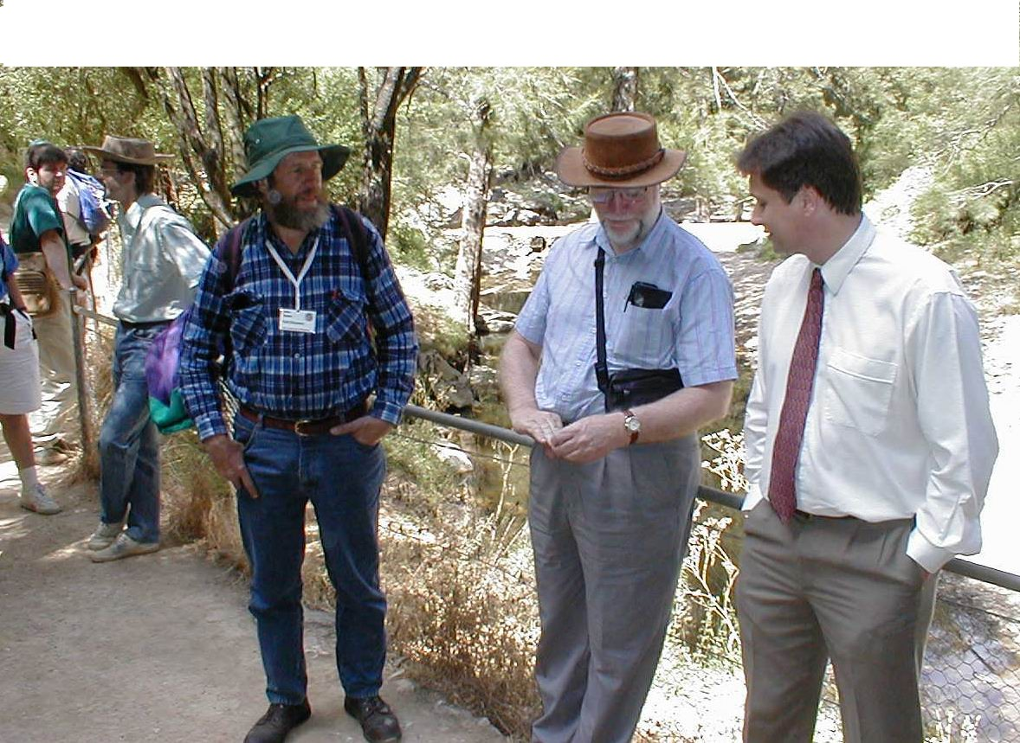
Outside Abercrombie cave Arthur Clarke

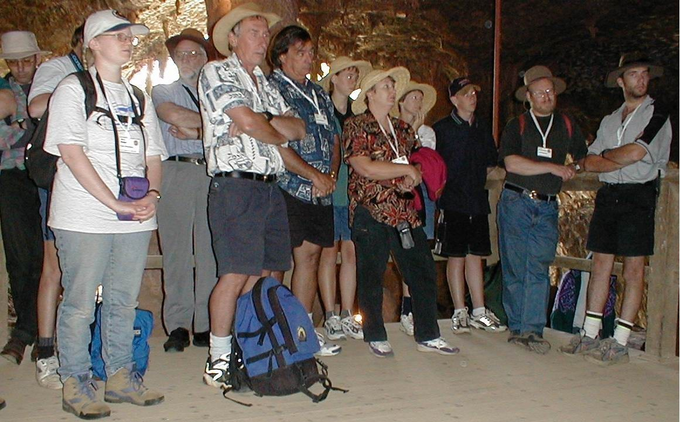

Inside Abercrombie Cave, listening to Arthur Clarke
Pat Larkin open the Conference

THE EQUILIBRIUM HYDROGEOCHEMISTRY OF DAVYS CREEK, CENTRAL NSW.

S.A. Lucas

ABSTRACT
Davys Creek (32º40' S, 148º40' E) is a tributary of the Belubula River in central western N.S.W. Springs that source Davys Creek are enriched in dissolved calcite (as Ca²⁺ and HCO₃⁻), resulting in one of the few calcite-precipitating streams in NSW. Coupled with atmospheric CO₂ degassing, calcite precipitation has been shown to occur in regions of stream turbulence, where CO₂ exsolution is at a maximum. Temperature influences the solubility of both Ca²⁺ and HCO₃⁻, and with samples taken over 16 months, this study allowed for seasonal interpretation. Results are consistent with previous research and present a valuable insight into the equilibrium hydrogeochemistry of Davys Creek.

BACKGROUND
The equilibrium chemistry of the CO₂/H₂O/CaCO₃ system is the dominant influence on karst systems (White, 1988; Gillieson, 1996), for it controls the dissolution and precipitation of rocks and minerals by natural waters and consequently the geomorphology of karst environments (Jennings, 1985; Ford, 1992). Table 1 introduces dominant equilibria reactions that occur along hydrological pathways within karst environments.

Table 1: Simplified processes of solution of calcium carbonate (Gillieson, 1996).
EQUATION KINETICS
CO_{2(g)} + H₂O CO_{2(aq)} + H₂O (slow) (1.1)
CO_{2(aq)} + H₂O H₂CO₃ (slow) (1.2)
H₂CO₃ H⁺ + HCO₃⁻ (fast) (1.3)
H⁺ + CO₃²⁻ HCO₃⁻ (fast) (1.4)
CaCO₃ Ca²⁺ + CO₃²⁻ (slow) (1.5)

Exposed limestone (as calcite (CaCO₃) rocks) occurs on about 20% of the Earth's surface (Langmuir, 1997). If mineral carbonates of calcium and magnesium are present at levels of >1%, they will tend to dominate the chemistry of the soil and groundwater (Langmuir, 1997). Dissolved limestone contributes calcium ions by the overall dissolution equation (Stumm and Morgan, 1996; Dreybrodt, 1998):

CaCO₃ + CO₂ + H₂O Ca²⁺ + 2HCO₃⁻ (1.6)

The relative calcium ion (Ca²⁺) concentration increases with respect to dissolved CO₂ (as HCO₃⁻), and as the solution becomes supersaturated, the reverse reaction of equation (1.6) may occur. The degree of saturation is usually determined with reference to the calcite saturation index:

SI_{c} = log (IAP_{c}/K_{c}) (1.7)

where IAP_{c} is the ion activity product (αCa²⁺. αCO₃²⁻) for a given water sample and K_{c} is the solubility product constant for calcite (Stumm and Morgan, 1996; Langmuir, 1997). For a supersaturated water, SI_{c} > 0, and for an under-saturated solution SI_{c} < 0. The further from 0, positive or negative, infers the degree of supersaturation or under-saturation respectively.

Spring water emerging at the Earth's surface will release carbon dioxide to attain atmospheric equilibrium through degassing, driving the SI_{c} upward (Ford, 1989; 1992). Degassing of CO₂ is enhanced by stream turbulence (Herman and Lorah, 1987; Liu et al, 1995) and an increase in water temperature (Drake, 1983; Dreybrodt et al., 1996). Aquatic vegetation also uses CO₂ during photosynthetic respiration (Ford, 1989; Ford & Pedley, 1996).

Spring water can be differentiated from surface water by hydrochemical analysis, i.e. a relatively lower pH, higher Ca²⁺ and HCO₃⁻ concentrations, a higher SC and a lower calcite saturation index (SI_{c}). These parameters vary as carbonate spring water flows downstream and gains atmospheric equilibrium, with respect to CO₂, and may result in calcite precipitation (Herman and Lorah, 1987; Liu et al, 1995; Drysdale et al, 1998).

Calcium carbonate is preferentially precipitated due to the lower solubilities of other ions in solution (Katz, 1973; Dreybrodt, 1988). For calcite to precipitate, a suitable nucleation site must be available (Dreybrodt, 1988). In solution, the presence of excess cations with larger ionic radii (ie, Mg²⁺) can inhibit calcite precipitation by decreasing the availability of suitable nucleation sites (Morse, 1983).

Calcite precipitation does not usually occur at the source of non-thermal springs due to the slow rate of CO₂ ex-solution. The degree of calcite saturation, governed on the surface by degassing, temperature and stream geomorphology, influence downstream CO₂ loss and control where calcite, if any, is deposited. Temperature affects the solubility of CO₂ and Ca²⁺ in solution and has been found to have an important influence on the equilibrium chemistry of carbonate ground waters (Drake, 1983) and spring waters (Liu et al, 1995).

SITE DESCRIPTION
Davys Creek exists on two private properties, namely "Boonderoo" and "North Werribee", approximately 30 km north east of Cowra and 50 km west south west of Orange. The Davys Creek catchment is comprised predominantly of andesite and limestone. The andesite (Walli Andesite) occupies around two-thirds of the upper surface catchment and has uplifted during the early to mid Ordovician (Webby and Packham, 1982).

The limestone unit (Cliefden Caves Limestone Group) occupies the lower third of the surface catchment and formed in the mid to late Ordovician (Webby and Packham, 1982). Consisting of seven sub-groups, the Cliefden Caves Limestone Group will be herein referred to as the "limestone" (Figure 1).

The limestone is heavily folded, with several fault lines transecting Davys Creek in a north west-south east direction. The exposed bedding planes of the limestone can be seen in places, particularly near contacts with the Walli Andesite. Block faulting has resulted in the older Walli Andesite being above the younger limestone (Hill, 1999).

The elevation of the Davys Creek catchment ranges from approximately 585 metres on the Walli Andesite, to around 400 metres at its confluence with the Belubula River. The Walli Andesite/ limestone contact can be seen to strike (NE-SW) across Davys Creek 3 km downstream from the head of the catchment, at an elevation of approximately 450 m.

A further 1 km downstream at an elevation of 430 metres, a small outcrop of exposed Walli Andesite exists within Davys Creek. Between the limestone, the exposed Walli Andesite outcrop covers a downstream distance of 150 metres, coinciding with the Wonga fault line (Figure 1). Limestone is present for the last 900 metres of Davys Creek.

Figure 1: Surface Geology of Davys Creek (Adapted from Webby and Packham, 1982)

HYDROLOGY & GEOMORPHOLOGY
Davys Creek commences on the Walli andesite to the south of the limestone. The first 600 metres of Davys Creek, on “North Werribee”, is dominated by two farm dams. No flow was observed between here and a conspicuous reed bed a further 500 metres downstream, ultimately becoming Site 1 (S1), the point chosen to begin this study.

The gradient is relatively low (Figure 2) from S1 to S4 where a further two farm dams exist. Downstream of the second farm dam, Davys Creek has incised through the thick alluvium forming terraces. Cattle use Davys Creek for drinking purposes and cause severe bank erosion in some areas on the Walli Andesite.

The gradient was relatively low along this reach, and sediment deposition was evident over the next 1 km. The sediment favoured deposition around willow trees, where the semi-exposed root systems captured larger debris during storm events, eventually forming the sediment dams observed.

Approximately 400 metres prior to the Walli Andesite/limestone contact, the gradient steepens through a rocky reach of Davys Creek. Calcite precipitation can be observed, in the form of tufa barrages, which contain encrusted sticks and tree branches. This continues to a weir, approximately 5 metres upstream of the Walli Andesite/limestone contact, where the largest tufa deposit on the Walli Andesite exists (~1 metre).

Downstream of the Walli Andesite/limestone contact, Davys Creek flows for another 300 metres before sinking into the limestone. The dry channel meanders through more alluvial terraces, much larger than the terraces observed on the Walli Andesite, for another 450 metres. Spring water emerges near the downstream Walli Andesite/limestone contact. Flowing onto the Walli Andesite outcrop, spring waters deposit tufa approximately 100 metres from the spring source. Fossil tufa deposits can be observed on the adjacent alluvial terraces of Davys Creek, inferring a higher stream position than the present day.

The gradient increases sharply over the next 500 metres through heavily folded limestone. Dominated by active tufa deposition, this reach displayed small tufa barrage systems and dams (~3 metres), forming a series of cascades and waterfalls. The gradient decreases substantially in the lower reaches, where flow continues until its confluence with the Belubula River a further 150 metres downstream.

METHODS
A monitoring schedule was implemented that involved up to 20 water sample sites, dependent on flow (Table 2). Sample sites were selected above, through, and below observed calcite precipitation sites, and also included spring sources, a sink, and an anthropogenic dam (Figure 2). Although numerous site visits were made, the four most extensive campaigns will be presented. The specific dates for the monitoring schedule are outlined below:

Table 2: Davys Creek field trips
DATE | NUMBER OF SAMPLES TAKEN
MAR99 - 13/3/1999 | 19
JULY99 - 24/7/1999 | 19
OCT99 -3/10/1999 | 20
FEB00 - 12/2/2000 | 19

Analysis was performed using a calibrated Eutech CyberScan PC10 hand held pH/Conductivity/Temperature Meter. Sample bottles were rinsed three times in creek water at the sample site before sampling. The sample bottle was then filled to capacity to minimise gas exchange, and reduce errors in the bicarbonate analyses (alkalinity) (APHA, 1998). The sample was filtered through a 0.45µm membrane filter, using a Millipore hand vacuum pump, to remove suspended solids.

After taking the required aliquot for bicarbonate (HCO₃⁻) analysis, which was analysed on site, the sample was mixed thoroughly and divided into two 100 ml sub-samples. One 100 ml bottle (cations) was acidified with 2 ml of concentrated nitric acid (HNO₃), and the other left non-acidified for anion analysis. Both were refrigerated below 4ºC and analysed within 7 days (APHA. 1998).

Cation analysis was performed using an ARL 3520 ICP-AES. Major cations analysed for were calcium (Ca²⁺), magnesium (Mg²⁺), sodium (Na⁺), and potassium (K⁺). The major anions measured for were bicarbonate (HCO₃⁻), chlorides (Cl⁻), sulfates (SO₄²⁻), and nitrates (NO₃⁻). Bicarbonate (HCO₃⁻) concentration was achieved by the potentiometric titration method against a dilute HCl solution, within 24 hours of sampling. Chlorides (Cl⁻), nitrates (NO₃⁻) and sulfates (SO₄²⁻) were measured using a WatersTM Ion Chromatograph (IC), using the IC method (APHA, 1998). Only results pertaining to changes in the CO₂/H₂O/CaCO₃ equilibrium system are presented during discussion.

RESULTS & DISCUSSION
Researchers have shown that regions of hydrochemical variability in carbonate water systems directly relate to regions of stream turbulence (Lorah & Herman, 1988; Lui & Dreybrodt, 1997; Drysdale & Gale, 1997). These regions were also deemed to be the most effective sites to measure the downstream evolution in the hydrogeochemistry of Davys Creek. Three segments of downstream hydrogeochemical evolution were identified, and for ease of discussion, will be interpreted separately.

Downstream variation in Ca²⁺ and HCO₃⁻ concentrations

Sites S1-S4
Spring water emerging at the uppermost spring in the Davys Creek catchment is saturated with dissolved CO₂ (as HCO₃⁻) and Ca²⁺. As spring water flows downstream, CO₂ degasses from solution to attain atmospheric equilibrium, and is reflected in the decreasing HCO₃⁻. In studies at Falling Spring Creek, Virginia USA, Herman and Lorah (1988) have shown that CO₂ is lost from solution immediately as water emerges from a carbonate spring, due to its tendency to equilibrate with the atmospheric CO2 gradient. Precipitation of calcite from a calcite-saturated solution will not happen immediately as supersaturation is reached and subsequently no calcite precipitation was observed in the immediate downstream vicinity of S1.

The increased residence time in pooled surface waters favoured evaporation and natural degassing, which appeared to be the main influences on decreasing HCO₃⁻ concentrations between S1 and S4. The ephemeral nature between S2 and S3 meant that discharge variation in surface flow at any one site was relatively large, from no surface flow to maximum flow during storm events. The first farm dam, prior to S2, acts as a surface storage for spring water from S1. Just as increased residence time underground increases the dissolved CO₂ concentration, increased residence time on the surface will allow the exposed water to atmospherically degass over time, until equilibrium is reached. Rainfall will also have a dilution effect during prolonged rain events.

Figure 2: Sample Sites and Long Profile of Davys Creek, central NSW.

Hydrogeochemical data also confirms that Ca²⁺ is lost from solution between S1 and S4 (Figure 3). Suarez (1983) studied the downstream variation in calcite saturation in the Colorado River, and noted that decreasing levels of Ca²⁺ can be measured without any observable calcite precipitation occurring. Apparently, the lack of suitable nucleation sites, short residence times, and the presence of calcite inhibiting organic matter on the river sediments did not allow for calcite precipitation.

The loss of Ca²⁺ over this reach cannot be observed in the field without referring to the data, with the lowest levels occurring in the second farm dam (S4). Data also infers the possibility of calcite precipitation on the bottom sediments of the second farm dam (S4), although this was not investigated.

Sites S6-S10
The diffuse discharge carbonate spring at S6 is identified from the high Ca²⁺, high HCO₃⁻ and low pH. Data suggests CO₂ degasses from solution as Davys Creek flows downstream to S8, where Ca²⁺ and HCO₃⁻ levels increase due to spring recharge. Spring water emerging at S8 had similar hydrogeochemistry to springs at S1 and S6 during each monitoring period (refer Figures 3,4 &5)4).

Although Ca²⁺ and HCO₃⁻ concentrations fall between S6 and S8, due to degassing, there is no observed evidence of calcite precipitation. Davys Creek has a relatively low gradient between S6 and S8, with sediment dams forming around mature Salix spp. Grasses and aquatic vegetation inhabit the channel between S6 and S8 with creek flow travelling below the sediment during drier periods. The gradient between S8 and S10 increases markedly (refer Figure 2). CO₂ loss is caused by an increase in hydrological agitation and is reflected in the decreasing HCO₃⁻. The relatively sharp decline in Ca²⁺ and HCO₃⁻ concentrations between S9 and S10 coincide with tufa deposition along this reach. The largest tufa deposit in the second evolutionary segment is located several metres upstream of S10, and is a consequence of enhanced degassing. Degassing is enhanced by the increased gradient, causing the formation of tufa barrages that further disperse flow as to increase the surface area exposed to the atmosphere.

On two occasions (March 1999 and February 2000) the HCO₃⁻ at S11 unexpectedly increased, while there was no increase in Ca²⁺ during the same periods. The increase in dissolved CO₂ (HCO₃⁻) from S10 to S11 is attributed to thick vegetation, with dissolved CO₂ recharge due to root zone respiration and long residence times. Mature Salix trees and several species of aquatic plants are present along this reach, and appear to thrive with the existing perennial flow. Sediment deposition occurs around the bases of Salix spp, with flow appearing to travel through sediment, and the root respiration zone of the existing vegetation. Observations and hydrogeochemical data suggest the influence of biogenic activity in Davys Creek can be quite substantial, although it was not investigated in this study.

Between S11 and S13 Davys Creek sank, or was pooled. S12 was deemed to be the likely dominant stream sink conduit, due to its location on a fault line. Fault lines are planes of weakness and are usually the largest conduits of sub-surface flow in karst landscapes (Gillieson, 1996). During the monitoring period, the shallow, dispersed nature of surface flow along this reach promoted CO₂ degassing, and was assumed to be the dominant process in CO₂ exsolution.

Sites S14-S19
The third evolutionary segment of carbonate spring waters starts approximately 400 metres from where Davys Creek sinks at S12. Springs emerging at S14 are saturated with Ca²⁺ and dissolved CO₂ and display a typical downstream trend in calcite precipitating streams. The rapid loss in Ca²⁺ and dissolved CO₂ between S16 and S18 is initiated by the increased hydrological agitation down this steeper reach.

The largest tufa deposit in Davys Creek is found at S17. The S16 to S17 reach consistently loses more dissolved CO₂ and Ca²⁺, over the shortest distance, than any other reach in this study. Tufa deposition occurs at sites of hydrological agitation and is consistent with previous research (Herman &Lorah, 1988; Hoffer-French & Lorah, 1989).

Water flows over tufa barrages and dams with degassing being enhanced by this increased agitation. From S17 onwards the surface flow of Davys Creek fans out into a sediment and vegetation filled region before narrowing again at S18. During the warmer months, grasses, lilies, and a multitude of weeds and small shrubs clog this reach of Davys Creek.

The gradient increases from S18 to S19 with degassing of CO₂ due to the atmospheric gradient deemed to be the dominant process in determining the downstream change in hydrogeochemistry. The combination of low flow and large exposed surface area of the channel both promoted degassing.

SEASONAL VARIATION
The consistency of the downstream trends observed infer that similar hydrogeochemical processes operate throughout the year. The downstream variation in temperature between S1 and S13 was no more than 4ºC during any one monitoring period. The major variation observed is the seasonal difference between spring sites on the Walli Andesite, and those on the limestone. The seasonal variation in temperature was found to be large enough (on average 7-20ºC) to infer that source waters for springs in the first two evolutionary segments experience short residence times. Seasonal temperatures of spring waters at S1, S6 and S8 appear to be indicative of the atmospheric temperature at the time of sampling.

In contrast, seasonal temperatures at S14 ranged between 16ºC and 17ºC throughout the year. It is known that cave systems have ambient air temperatures that relate to the annual average atmospheric temperature (Harmon et al, 1978), and it was assumed that a well-developed conduit system existed under the limestone in the third evolutionary segment.
The lack of variation in seasonal temperature at S14 means that source waters have been in contact long enough to equilibrate with the temperature of the underlying conduit/cave system. This is particularly evident in July 1999, when spring sites in the first two segments registered a temperature of approximately 6ºC, compared to 16ºC at S14.

Research by McDonald (2000) in a local cave (Murder Cave) found the air temperature to be 16.2 ºC, which is in almost perfect agreement with seasonal temperature data for S14. Also, the larger downstream variation in atmospheric temperature in the third evolutionary segment is a result of ground waters trying to equilibrate with surface temperatures, and confirms the short response time to temperature in Davys Creek.

As temperature governs the processes described in Davys Creek, it is no surprise to find that dissolved CO₂ and Ca²⁺ are also affected. On close examination it can be seen that seasonal trends are basically similar, but are raised or lowered with respect to the seasonal temperature variation observed.

In the case of HCO₃⁻, it has been shown that lower temperatures allow for greater solubility of dissolved CO₂ (Lucas, 2000), hence the downstream HCO₃⁻ trend for the coldest monitoring period (July 1999) is generally higher than other months. With Ca²⁺ concentrations the variation is not as pronounced, but the trend is similar in calcite precipitating regions (S8-S10 and S15-S18).

CALCITE PRECIPITATION (S8-S10 and S15-S17)
The calcite-saturated ground waters feeding Davys Creek have a propensity to precipitate calcite at specific sites. These sites were recognised in the downstream trends observed, as well as visual confirmation. Only two of the three evolutionary segments identified undergo tufa deposition. Of interest is the fact that tufa deposition between S8 and S10 occurs on the Walli Andesite, which is quite uncommon.

Between S8 and S10, a series of tufa barrages ranging between 0.01 and 1 metre were observed. The average gradient along this reach was 0.03 m/m, with significant hydrological agitation being observed. Tufa deposits at the lower end of this reach were larger than the ones observed near S8, and can be seen in the steeper decline in seasonal Ca²⁺ concentrations between S9 and S10. This is in agreement with tufa deposition occurring further from the spring source (Herman & Lorah, 1987).

Average Ca²⁺ loss between S8 and S10 (~ 1.5 km in distance) ranged from 11 mg/L in July 1999 to 48 mg/L in February 2000. In March 1999 and July 1999, this reach lost 25 mg/l and 14 mg/L respectively. The large variation infers a preference for tufa deposition in the warmer months, when degassing and plant respiration are at a maximum. This preference is related to the seasonal temperature fluctuation in ground waters feeding Davys Creek, especially at S6.

The rate of Ca²⁺ loss in October 1999 has diminished in terms of the slope of the trend line observed and was attributed to the recorded, relatively larger, total monthly rainfall. This would have had a dilution effect from dam and surface runoff, thus decreasing the rate of tufa deposition. Note that hydrological agitation was assumed constant throughout the monitoring period.

In the third evolutionary segment, between S15 and S17, a similar trend is observed. The relatively constant seasonal temperatures recorded at S14 proved that source waters were in contact with limestone for a long enough time to equilibrate to conduit temperature conditions. Due to the lack of variation in the temperature of source waters for the calcite precipitating reach between S15 and S17, the seasonal downstream trends are almost identical.
The rate of Ca²⁺ loss ranges from 26 mg/L in February 2000 to 44 mg/L in March 1999. In July 1999 and October 1999, 32 mg/L and 34 mg/L of Ca²⁺ were lost respectively. The relatively small variation in downstream seasonal temperature, with the exception of May 1999, infers a relatively uniform tufa deposition rate. Including May 1999, and under assumed constant hydrological agitation, tufa deposition shows little seasonal preference along this reach.

CONCLUSION
Spring waters that source Davys Creek exhibit a significant change in their hydrogeochemistry as they flow downstream. Due to equilibrium shifts in the CO₂/H₂O/CaCO₃ system, the ability of flowing spring water to maintain the dissolved Ca²⁺ load is decreased (increasing the SI_{c}), resulting in calcite precipitation. The gradient of the creek channel enhances stream turbulence, further favouring calcite precipitation at these sites. It appears that the greater the rate of CO₂ exsolution, over the shortest downstream distance, will be the most probable site of calcite precipitation.

The seasonal temperature variation of spring waters, in the upper two segments, is large enough to infer low residence times in the aquifer sourcing these springs (S1, S6, and S8). This is implied from the similarity of atmospheric temperatures to those of the samples taken. The seasonal preference for calcite precipitation in the S8-S10 reach is purely dependent on the solubility of calcite, over a range of temperatures (Dreybrodt, 1988). Results show the larger the range in seasonal temperature, the larger the deficit between summer and winter calcite precipitation.

References:

Clesceri, L.S; Greenberg, A.E; Eaton, A.D. (editors) (1998) Standard Methods for the
Examination of Water and Wastewater, 20th Ed, American Public Health Association (APHA),
Washington DC.

Drake, J.J (1983), The effects of geomorphology and seasonality on the chemistry of carbonate
groundwater, Journal of Hydrology, 61, pp223-236.

Dreybrodt, W. (1988) Processes in Karst Systems: physics, chemistry, and geology.
Springer-Verlag, 228pp.

Dreybrodt, W., Lauckner, J.; Liu Zaihua.; Svensson, U., and Buhman, D. (1996), The kinetics of
the reaction CO₂ + H₂O - H⁺ + HCO₃- as one of the rate limiting steps for the dissolution of
calcite in the system H₂O - CO₂ - CaCO₃, Geochima et Cosmochimica Acta, 60, pp3375- 3381.

Drysdale, R.N., and Gale, S.J. (1997) The Indarri falls Dam, Lawn Hill Creek, Northwest
Queensland, Australia, Earth Surface Processes and Landforms, 22, pp413-418.

Drysdale, R.N., Gale, S.J., Scherrer, N.C and Fischer, M.J. (1998) The chemistry of karst waters,

northeastern Barkley Tableland, northwest Queensland. In Comben, L, Long, S. and Berg, K.

(eds) Musselbrook Scientific Report, Geography Monograph Series 4, RGSQ, Brisbane,

pp97-124.

Ford, T.D. (1989) Tufa - the Whole Dam Story, Cave Science, 16, No2, pp39-49.

Ford, D.C. (1992) Karst Geomorphology and Hydrology. Chapman & Hall, Melbourne.

Ford, T.D.,and Pedley, H.M. (1996) A review of tufa and travertine deposits of the world,
Earth Science Reviews, 41, pp117-175.

Gillieson, G.S. (1996) Caves. Blackwell, Oxford, pp68-76.

Harmon, R.S., Schwarcz, H.P., & Ford, D.C. (1978) Satble Isotope Geochemistry of
Speleothems and Cave Waters from The Flint Ridge - Mammoth Cave System, Kentucky:
Implications for Terrestrial Climate Change During the Period 230,000 to 100,000 Years
B.P. Journal of Geology, 86, pp373-384

Herman, J.S and Lorah, M.M. (1988) Calcite precipitation rates in the field: Measurement and
prediction for a travertine-depositing stream, Geochima et Cosmochimica Acta, 52,
pp2347-2355.

Herman, J.S and Lorah, M.M. (1987) CO₂ outgassing and calcite precipitation in Falling
Spring Creek, Virginia, USA, Chemical Geology, 62, pp251-262.

Hill, W.L. (1999) A Report on an Examination of Dryland Salinity Processes on Three
Central West New South Wales Farms. Masters Thesis, Faculty of Sciences, University of
New England, NSW, Australia.

Hoffer-French, K.J., and Herman, J.S. (1989) Evaluation of Hydrological and Biological
Influences on CO₂ Flux from a Karst System, Journal of Hydrology, 108, pp189-212.

Jennings, J.N. (1985) Karst Geomorphology, Basil Blackwell, Oxford, pp1-7, 19-25, 34-69.

Langmuir, D. (1997) Aqueous Environmental Geochemistry. Prentice Hall: New Jersey.

pp193-230.

Liu Zaihua, Svensson, U., Dreybrodt, W., Yuan Daoxian, and Buhman, D. (1995),Hydrodynamic
control of inorganic calcite precipitation in Huanlong Ravine, China: Field measurements and
theoretical prediction of deposition rates, Geochima et Cosmochimica Acta, 59, pp3087-3097.

Liu Zaihua and Dreybrodt, W. (1997) Dissolution kinetics of calcium carbonate mineral in
H₂O - CO₂ solutions in turbulent flow: The role of the diffusion boundary layer and the slow
reaction CO₂ + H₂O -→ H⁺ + HCO₃⁻. Geochima et Cosmochimica Acta., 61, 2879-2889.

Lorah, M.M., and Herman, J.S. (1988) The Chemical Evolution of a Travertine-Depositing
Stream: Geochemical Process and Mass Transfer Reactions. Water Resources Research, 24,
pp1541-1552.

Lucas, S.A. (2000) The Downstream Hydrogeochemistry of Carbonate Spring Waters in Davys
Creek, central NSW. Honours Thesis, School of Geosciences, University of Newcastle, Aus.

McDonald, J. (2000) Late Quarternary Paleoclimate Reconstruction of Central N.S.W. as
inferred from stable Isotope and Trace Element Geochemistry of Speleothems, Honours
Thesis, University of Newcastle, Aus.

Saurez, D.L. (1983) Calcite saturation and precipitation kinetics in the lower Colorado River,
All-American Canal and East Highland Canal. Water Resources Research, 19, 653-661.

Stumm, W. and Morgan, J.J. (1980) Aquatic Chemistry, 3rd Ed. John Wiley and Sons, New
York. pp1022.

Webby, B.D. and Packham, G.H, (1982) Stratigraphy and regional setting of the Cliefden
Caves Limestone Group (Late Ordovician), central-western New South Wales. Journal of
the Geological Society of Australia, 29, pp297-317.

White, W.B. (1988) Geomorphology and Hydrology of Karst Terrains. Oxford University
Press: New York.

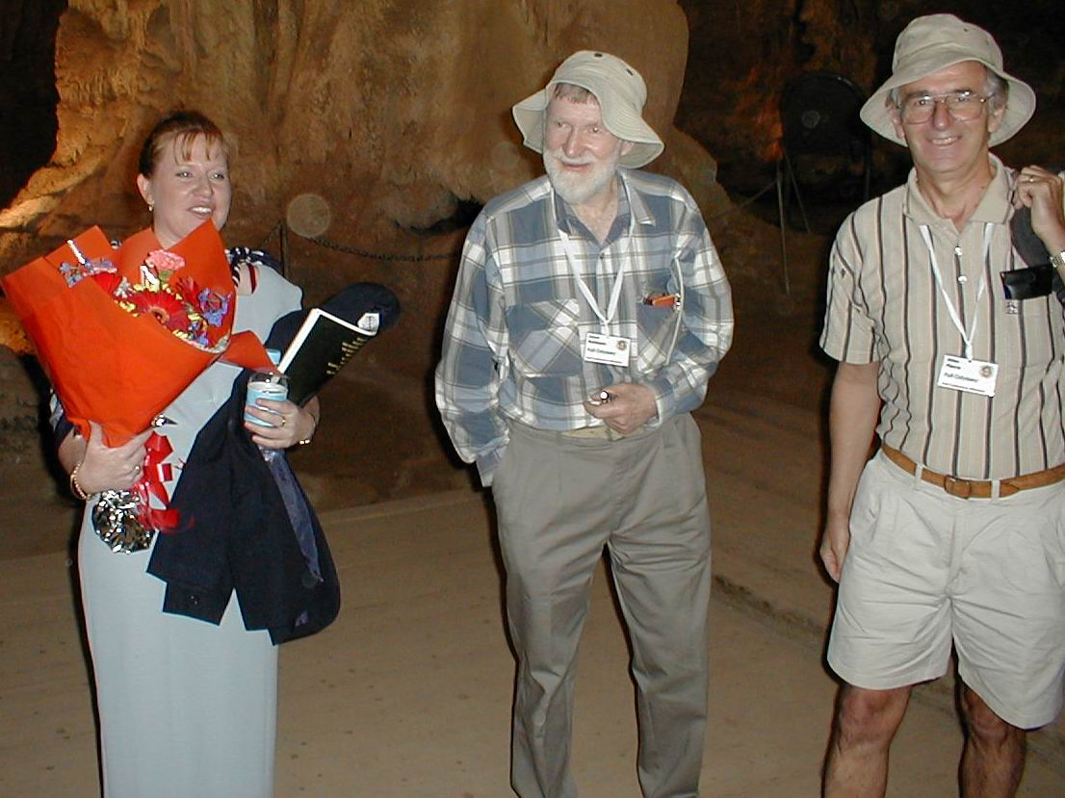
Arthur Clarke

Domino, Lloyd Robinson and Miles Pierce at Conference opening at Abercrombie Caves

